3elissa Jr. Mini-Rover In School Engineering Notebook Science-Fair Edition



– Written & Edited by E. Lahiani.

# Table of content:

| 2- General Introduction:  2.1 Who exactly are we?  2.2 Team Membres  2.3 Mentors | 1 |
| --- | --- |
| 3- Picking a problem:  3.1 Problem(1): Pollution  3.2 Problem(2): Education | 1 - 2 |
| 4- Coming up with the solution:  4.1 Research  4.2 Final solution | 3 |
| 5- Building our solution:  5.1 Designing the outer shell  5.2 List of electronics in the kit  5.3 Wiring the electronics  5.4 Building the full mechanism | 4 - 5 - 6 |
| 6- Coding the electronic parts:  6.1 General Information  6.2 Coding with explanation  6.3 Full code | 7 - 8 - 9 |
| 7- Full 3ellisssa Jr. Course  7.1 Our Meeting Gallery | 10 |
| 8- Resources & Credits | 10 - 11 - 12 |

# General Introduction:

In this section, we introduce ourselves and our mentors.

## **2.1 Who exactly are we?**

We are Team Ares participating in the “Youth For Science Science Fair 2022 Edition”. Our team is composed of 3 Tunisian high school students and mentored by 2 outstanding mentors. We are members of the First Skills Club Association, a Tunisian non-profit organisation currently located in Sfax.

Without further ado, this is our engineering notebook, highlighting every step we went through in detail when coming up then later on making our dream a reality.

## **2.2 Team Members:**

| Eya Lahiani, 15  Engineering Notebook Writer - Organiser  Coach in the First Skills Club | Mohammed Hedi Ben Jmeaa, 15  Incharge of designing, media and wiring  Coach In the First Skills Club | Mahdi Madani, 15  Incharge of wiring of the electronics  Assistant in the First Skills Club |
| --- | --- | --- |

## **2.3 Mentors:**

| Ms. Faten Khalfallah Hammouda  Mentor | Mr. Rabbah Hammouda  Mentor |
| --- | --- |

# Picking a problem

Throughout this section, we will be talking about how exactly we thought about the problems we decided to solve in our final project.

## **3.1 Problem(1): Pollution.**

Pollution has been a major problem all over the globe, especially in Tunisia as all of our energy sources produce side-effects that could cause long-term damage to our globe.

From non-recyclable plastic waste to excessive carbon use and emissions, we Tunisians produce tons and tons of inorganic waste each year, that if not collected then treated properly, will surely make our existence a living hell.

Lately, [available data](https://www.google.com/url?sa=t&rct=j&q=&esrc=s&source=web&cd=&cad=rja&uact=8&ved=2ahUKEwjNgvqFudv1AhWLiP0HHaJ0DxMQFnoECBoQAw&url=https%3A%2F%2Fwww.iamat.org%2Fcountry%2Ftunisia%2Frisk%2Fair-pollution&usg=AOvVaw1w8oWLhVjBVDwqmaVCX_fc) indicates that, in Tunisia; Bizerte, Sfax, Sousse, and Tunis are cities with consistently high levels of air pollution mostly due to land pollution as a first contributor.

And with the trash problem our city, Sfax, has been struggling with for the past few months, we decided to take initiative and help as well.

[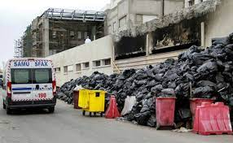](https://www.google.com/imgres?imgurl=https%3A%2F%2Fimg-s-msn-com.akamaized.net%2Ftenant%2Famp%2Fentityid%2FAAQoECN.img%3Fh%3D0%26w%3D600%26m%3D6%26q%3D60%26u%3Dt%26o%3Df%26l%3Df&imgrefurl=https%3A%2F%2Fwww.msn.com%2Fen-us%2Fnews%2Fworld%2Fresidents-activists-cry-foul-over-stinking-garbage-in-tunisia-s-sfax%2Far-AAQoCqH&tbnid=us6ZD_kwfLunSM&vet=12ahUKEwiU0rXDutv1AhVRg6QKHTDOAcUQMygCegQIARBE..i&docid=Z0RA8HivFnlIYM&w=599&h=370&q=trash%20in%20sfax&client=opera&ved=2ahUKEwiU0rXDutv1AhVRg6QKHTDOAcUQMygCegQIARBE)[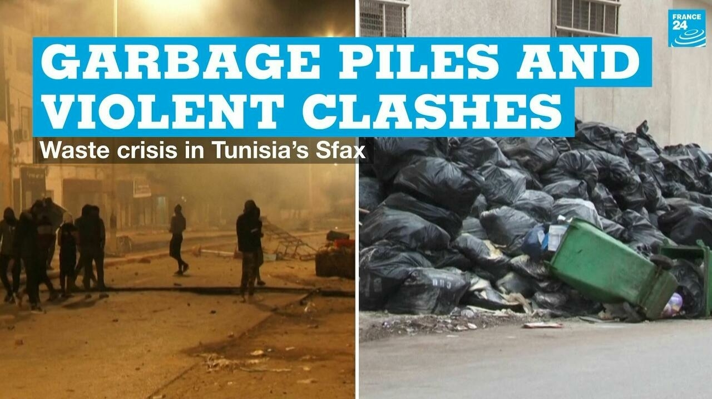](https://www.france24.com/en/video/20211110-garbage-piles-and-violent-clashes-the-waste-crisis-roiling-tunisia-s-sfax)[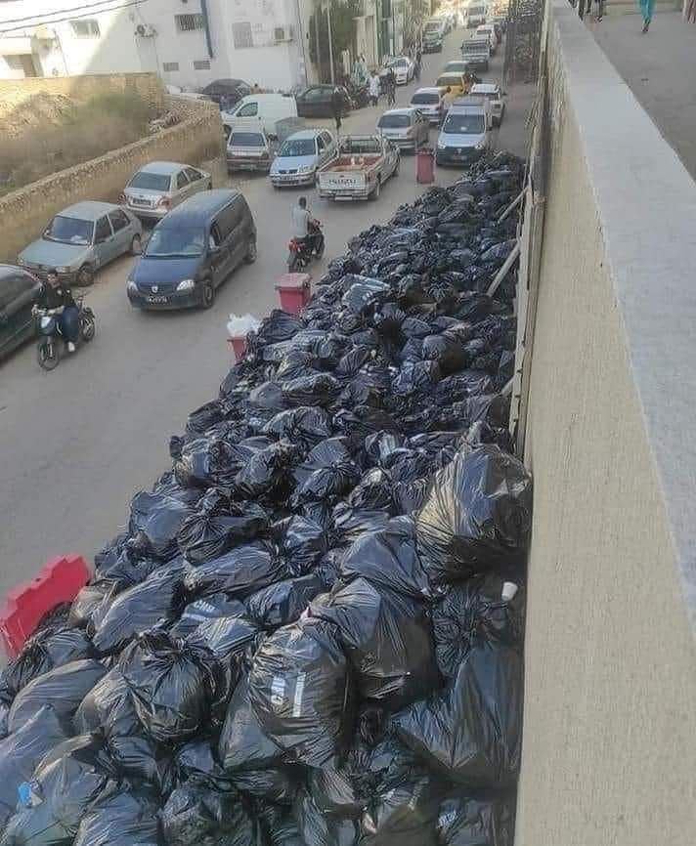](https://www.google.com/url?sa=i&url=https%3A%2F%2Fnews-tunisia.tunisienumerique.com%2Ftunisia-photo-of-the-day-garbage-still-invades-the-roads-of-sfax%2F&psig=AOvVaw0LZk1WGrq5NL3Fs_uqTMpD&ust=1643700195477000&source=images&cd=vfe&ved=0CAsQjRxqFwoTCKj2ltq62_UCFQAAAAAdAAAAABAP)

(These are real-life pictures. Sources to their rightful owners are linked within them.)

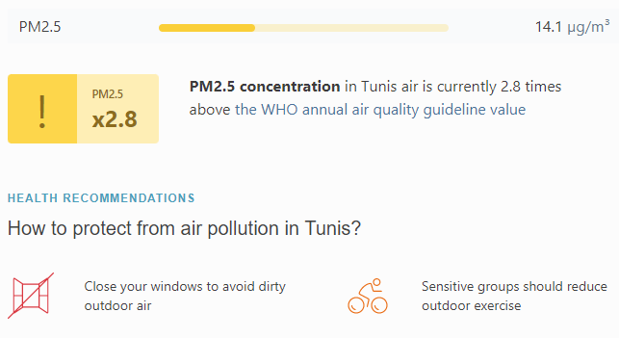  
<https://www.iqair.com/tunisia/tunis>

## **3.2. Problem(2): Education.**

Now, pollution is one problem to solve, but… Sadly, pollution isn’t the only problem our country is constantly suffering from as poor education has also been a big factor for the immense crime rate we are seeing among teenagers and tweens (people of the ages between 9-29).

[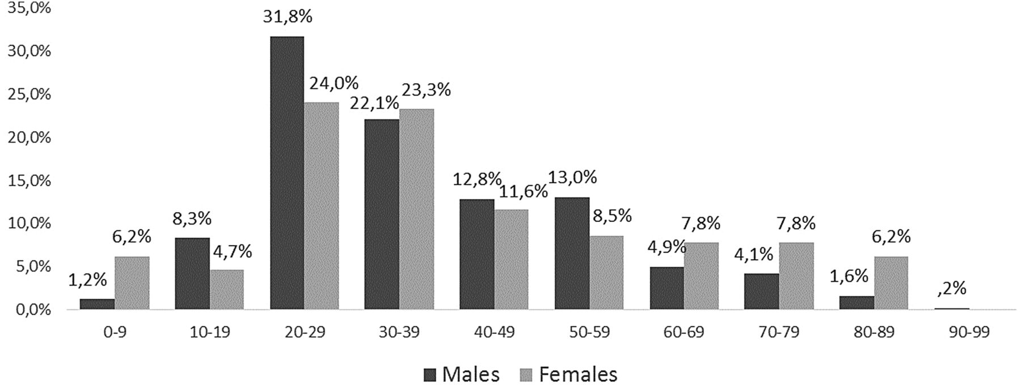](https://www.google.com/url?sa=i&url=https%3A%2F%2Finjuryprevention.bmj.com%2Fcontent%2F24%2F1%2F73&psig=AOvVaw1bXeJnn0sXQHnGpF63TeOw&ust=1643700568326000&source=images&cd=vfe&ved=0CAwQjhxqFwoTCNjnife72_UCFQAAAAAdAAAAABAK)

Not only that but an estimate of [about 100,000 children](https://open.unicef.org/sites/transparency/files/2020-06/Tunisia-TP6-2018.pdf)in Tunisia are currently out of school. Now, ***that’s*** truly heartbreaking.

[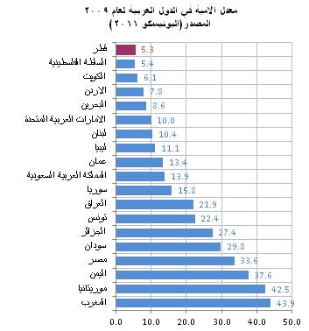](https://www.google.com/url?sa=i&url=https%3A%2F%2Fm.al-sharq.com%2Farticle%2F11%2F01%2F2014%2F%25D9%2582%25D8%25B7%25D8%25B1-%25D8%25AE%25D8%25A7%25D9%2584%25D9%258A%25D8%25A9-%25D9%2585%25D9%2586-%25D8%25A7%25D9%2584%25D8%25A3%25D9%2585%25D9%258A%25D8%25A9-%25D9%2581%25D9%258A-%25D8%25A7%25D9%2584%25D8%25B9%25D8%25A7%25D9%2585-2015&psig=AOvVaw0nQA-mZYRifQ5V7Zhupkuo&ust=1643700811725000&source=images&cd=vfe&ved=0CAwQjhxqFwoTCLiMu-q82_UCFQAAAAAdAAAAABAJ)[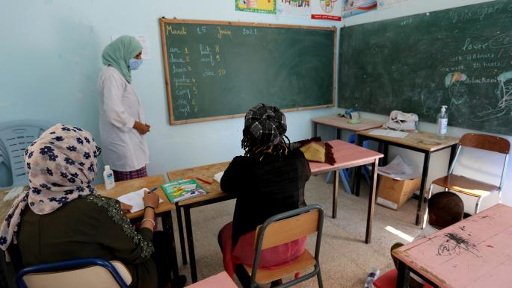](https://www.alaraby.co.uk/society/%D8%AA%D9%88%D9%86%D8%B3-%D8%A7%D9%84%D8%A3%D9%85%D9%8A%D8%A9-%D8%AA%D9%86%D8%AA%D8%B4%D8%B1-%D8%A8%D9%8A%D9%86-17-%D9%85%D9%86-%D8%A7%D9%84%D8%A8%D8%A7%D9%84%D8%BA%D9%8A%D9%86)

All of that is partially due to the excessive amount of tests we students sit through (about 80+ per year) and the inefficiency of such an old method in our generation and all the other generations to come.

# Coming up with the solution.

## **4.1 Research:**

That’s when we decided to contribute to fixing these issues.

We made [forms](https://docs.google.com/forms/d/1Z5Tg4DbuWyvPtgsL7-UR3yr-FGMPmdJZ2W21kILXa3M/prefill), searched through articles all over the internet, read books, [attended conferences](https://fb.watch/aTgBNj8tim/) … and we finally decided that it would be beneficial if instead of having the Computer Science and Technology classes be individual class of their own, why not merge them and make the students’ full marks in them be a project for the end of each term.

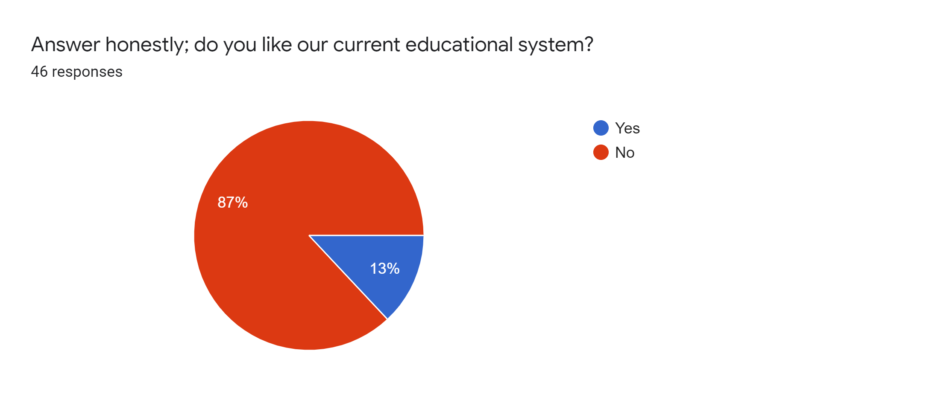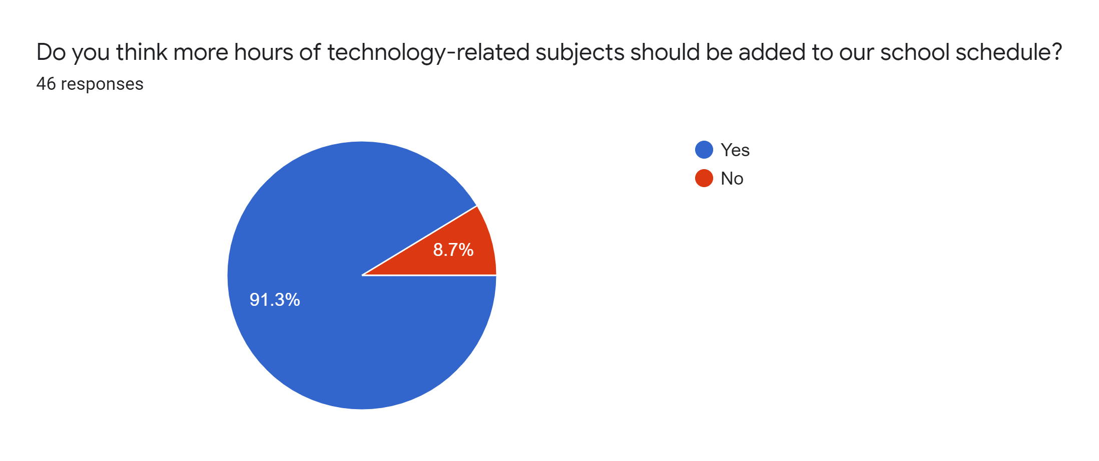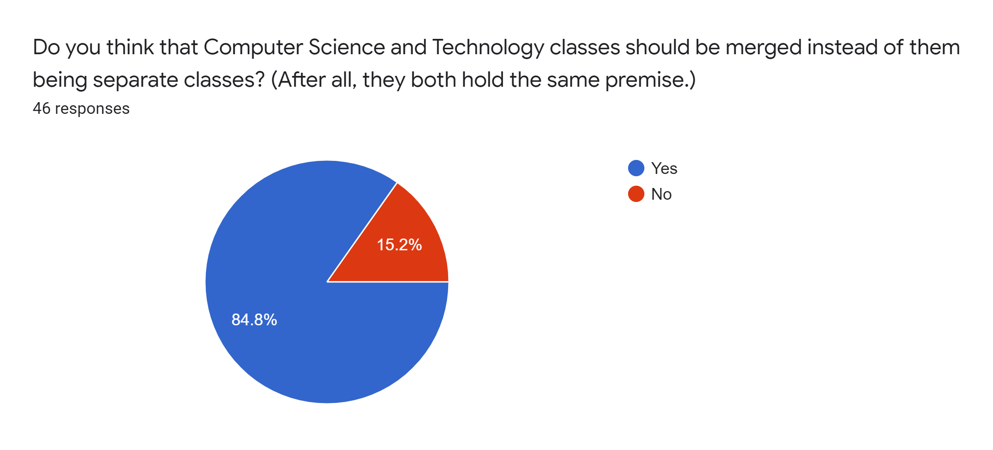

As can be seen from above, many pupils agreed with our idea, as they thought that it would teach them more about communication and project management skills than any test on paper would (We’re really sad to say that, yes, computer science and technology tests are done on paper.).

⇒ And this is where our invention, 3ellissa Jr., comes into play, hitting not one, not two, but three birds with one rock!

## **4.2 Final solution:**

A mini-rover, made wholly by Tunisian 15-year-old teenagers. A way of unleashing students' imagination and creation abilities, teaching them at the same time to communicate and manage a project. All of that in the sole purpose of solving Tunisia’s environmental problems through, of course, our designed step-by-step course. The mechanism is driven by phone (through a Bluetooth Module) to detect (via an Ultrasonic Sensor) and then collect trash laying on the ground using its intake arm that is, itself, powered by solar energy. The trash later on is put in a bag inside of the mini-rover.

This may seem simple at first, useless and trivial even but for young students who were probably never introduced to mechanics and coding except on paper, who struggle to learn by heart those long Arabic essays about our societal problems and who never got the opportunity to work on a project that solves those problems we seem to never stop talking about in a team, this experience would teach them a lot!

# Building our solution:

## **5.1 Designing the outer shell:**

We used the free version of SketchUp to make the design for the outer shell and this is the process we took throughout our designing:

It started out like this:

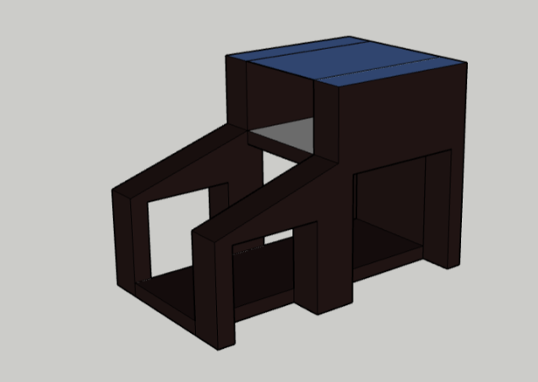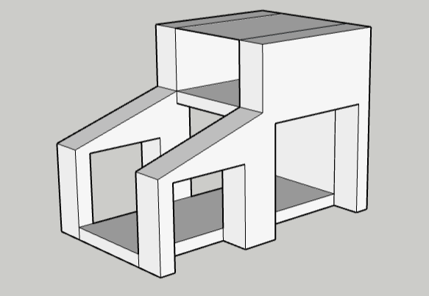

However, this design has some huge inefficiencies as we didn’t take it absolutely seriously. Thus, we decided to start over and work with a more mathematical/technical approach:

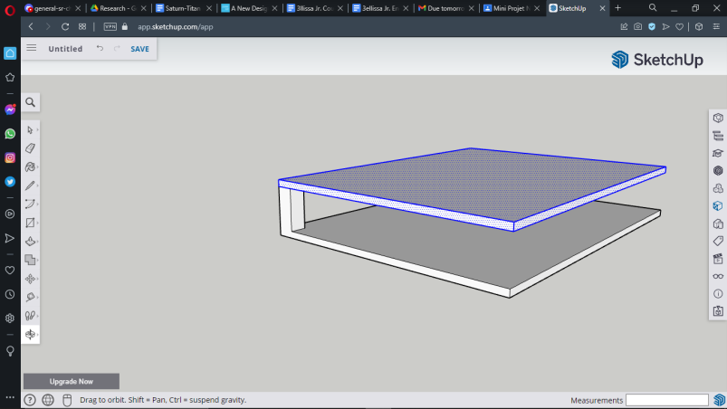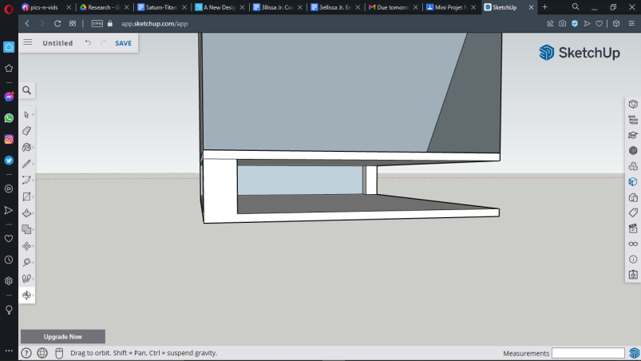

- The base for the electronics - Standing bars to help holding up the weight 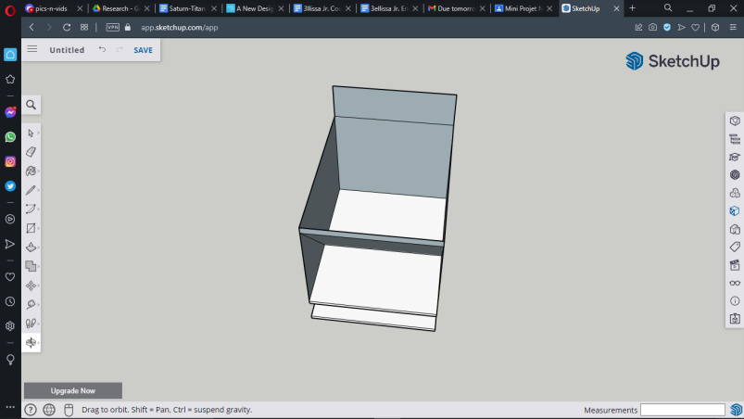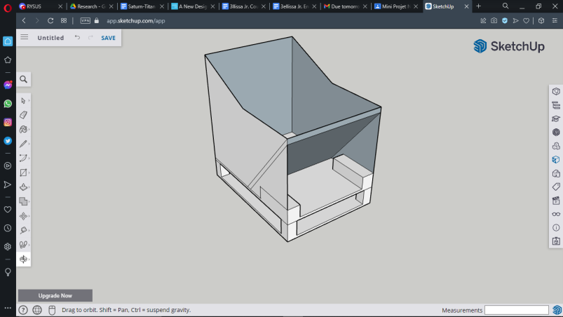

The outer shell is now standing high at 20cm by 15cm

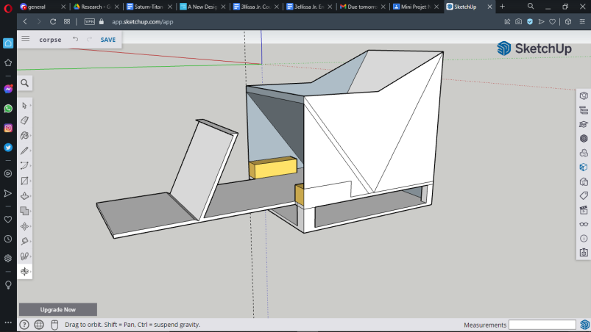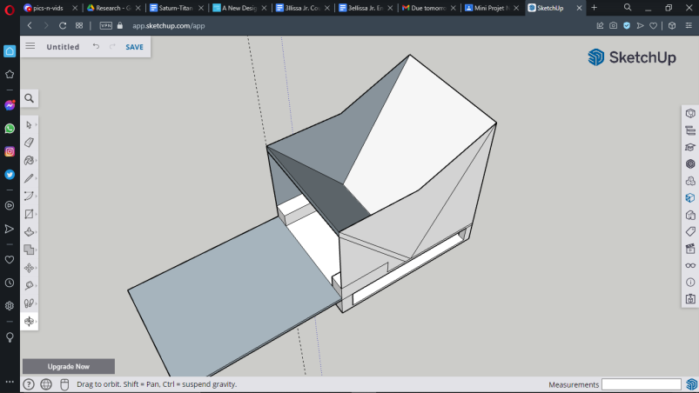

- The intake arm starts to appear - The trash place at centre of gravity to help balance

**Final Product:**

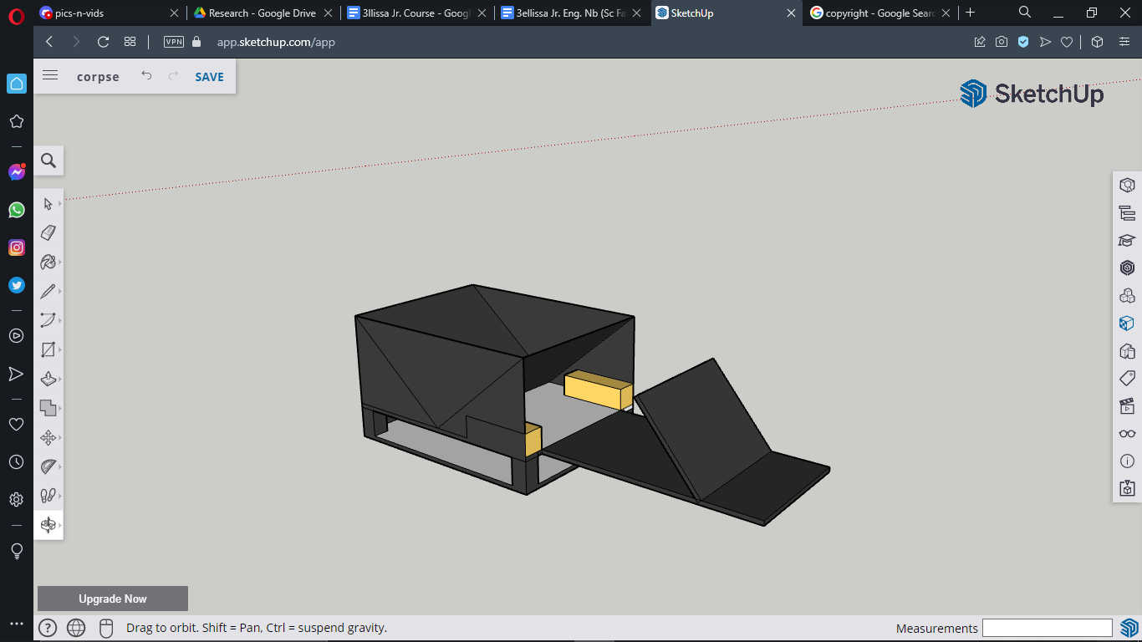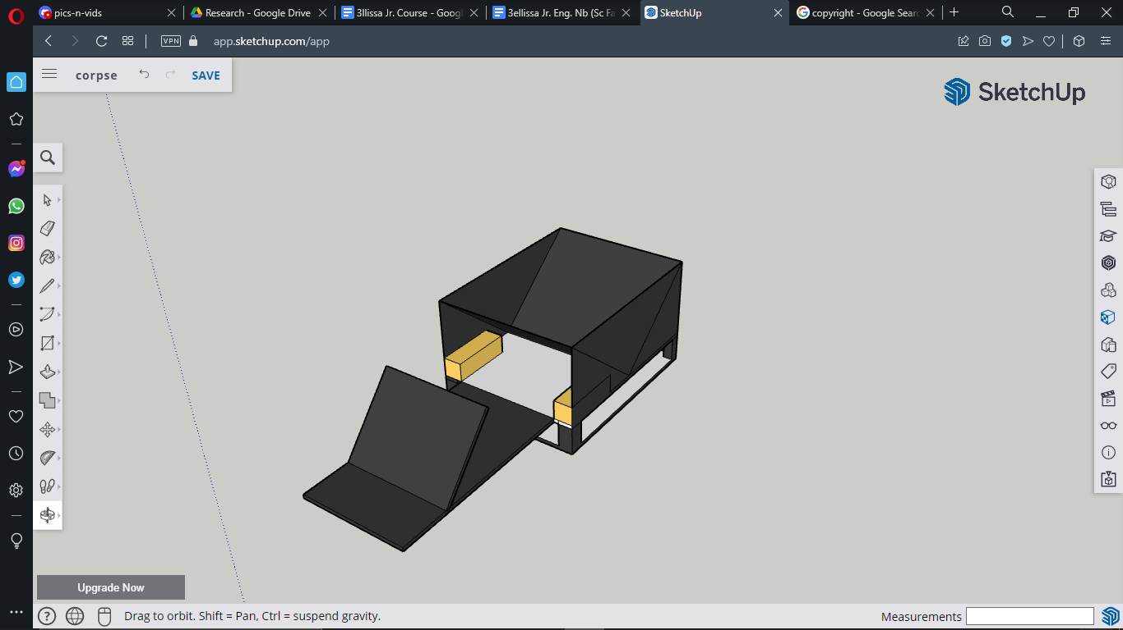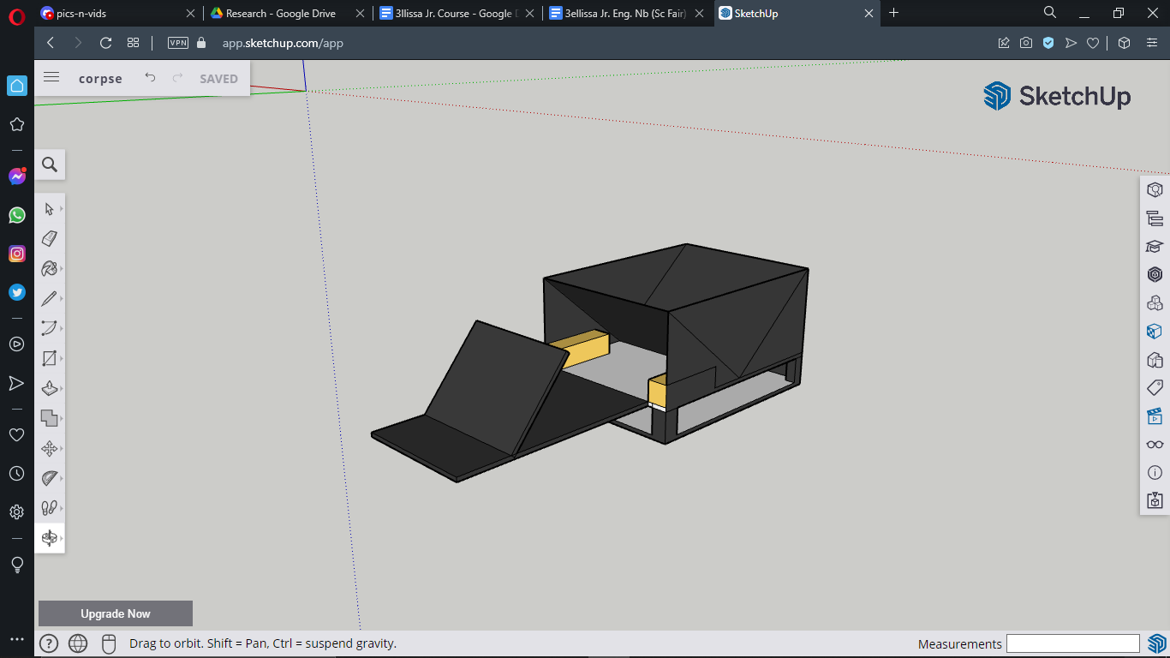

– Designed By E. Lahiani  
On 2022 / 02 / 20

## **5.2 List of electronics in the kit:**

| **Quantity, name and image of the product:** | **Description of the product / Links:** |
| --- | --- |
| 2 x L298N Motor Driver Module | This L298N Motor Driver Module is a high power motor driver module for driving DC and Stepper Motors. L298N Module can control up to 4 DC motors, or 2 DC motors with directional and speed control. |
| 1 x Arduino Uno | The Arduino Uno is an open-source microcontroller board. The board is equipped with sets of digital and analog input/output pins that may be interfaced to various expansion boards and other circuits. |
| 1 x Solar Panels / 9V battery | A solar panel works by allowing photons (particles of light) to knock electrons free from atoms, generating a flow of electricity. Solar panels actually comprise many, smaller units called photovoltaic cells. Many cells linked together make up a solar panel. |
| 4 x DC Motors | Connecting an L298 bridge IC to an Arduino enables the functioning of D(irect)C(urrent) motors. DC motors normally have just two leads, one positive and one negative. If connected directly to a battery, the motors will rotate. |
| 1 x HC-08 Bluetooth Module | HC-06 bluetooth module is a slave bluetooth module designed for wireless serial communication. It is a slave module meaning that it can receive serial data when serial data is sent out from a master bluetooth device (able to send serial data through air: smart phones, PC). |
| 1x HC-SR04 Ultrasonic Sensor | The HC-SR04 ultrasonic sensor uses SONAR (it’s a technique that uses sound propagation to navigate, measure distances...) to determine the distance of an object just like the bats do. It offers excellent non-contact range detection with high accuracy and stable readings in an easy-to-use package from 2 cm to 400 cm. |
| 2 x 6cm in diameter wheels 2 x 9cm in diameter wheels | Learn more here:   * <https://www.vexrobotics.com/228-3505.html> * <https://www.revrobotics.com/rev-41-1267/> |

⇒ All these products are all available in Tunisia for cheap prices. They are also easy to code, making them the best guide for pupils through making their very first invention.

## **5.3 Wiring the electronics:**

- Wiring the motors and the L298N Motor Driver Module:

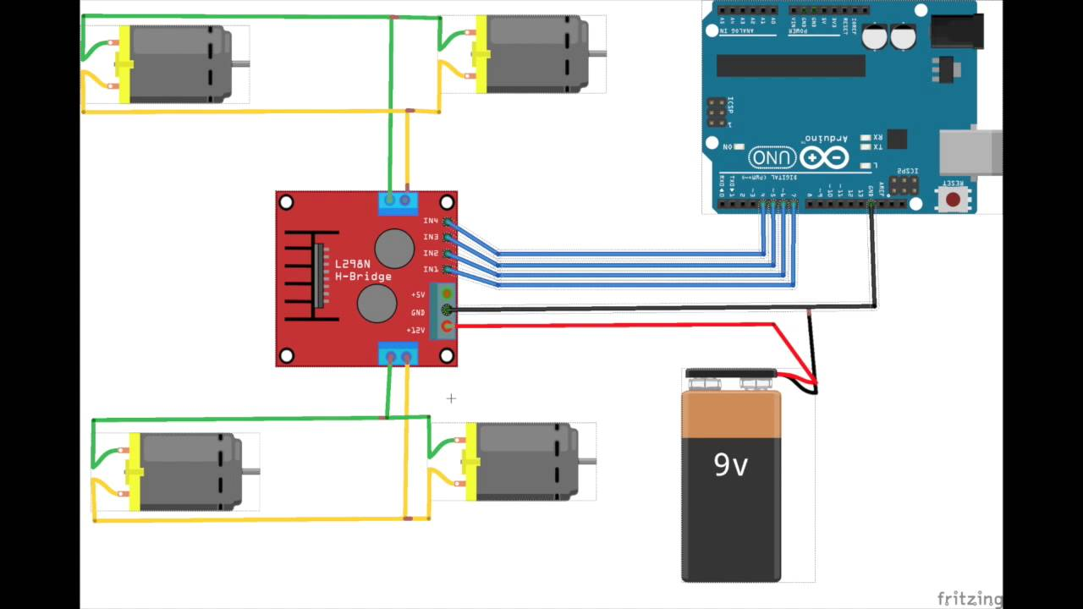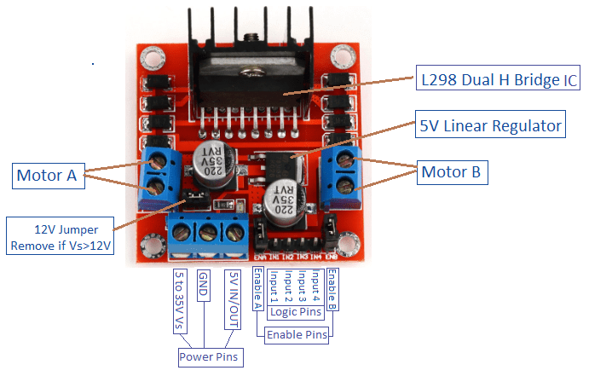

- Wiring the HC-08 Bluetooth Module:

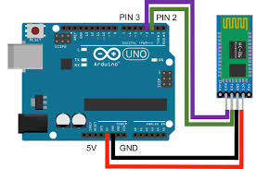

- Wiring the HC-SR04 Ultrasonic Sensor:

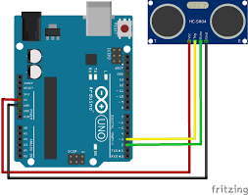

## **5.4 Building the full mechanism:**

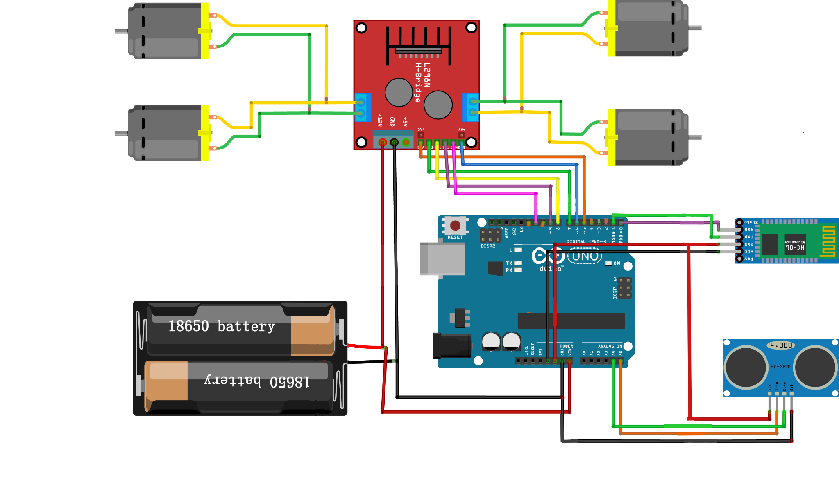

# Coding the electronic parts:

## **6.1 General Information:**

Arduino code is written in C++ with an addition of special methods and functions. C++ is a human-readable programming language. To download the coding environment, visit the official arduino website [here](https://www.arduino.cc/en/software). Once downloaded, you will be able to create a 'sketch' (the name given to Arduino code files), which will be processed and compiled to machine language when uploaded to your board after plugging in the (usually) blue wire.

**Downloading the driving app:**

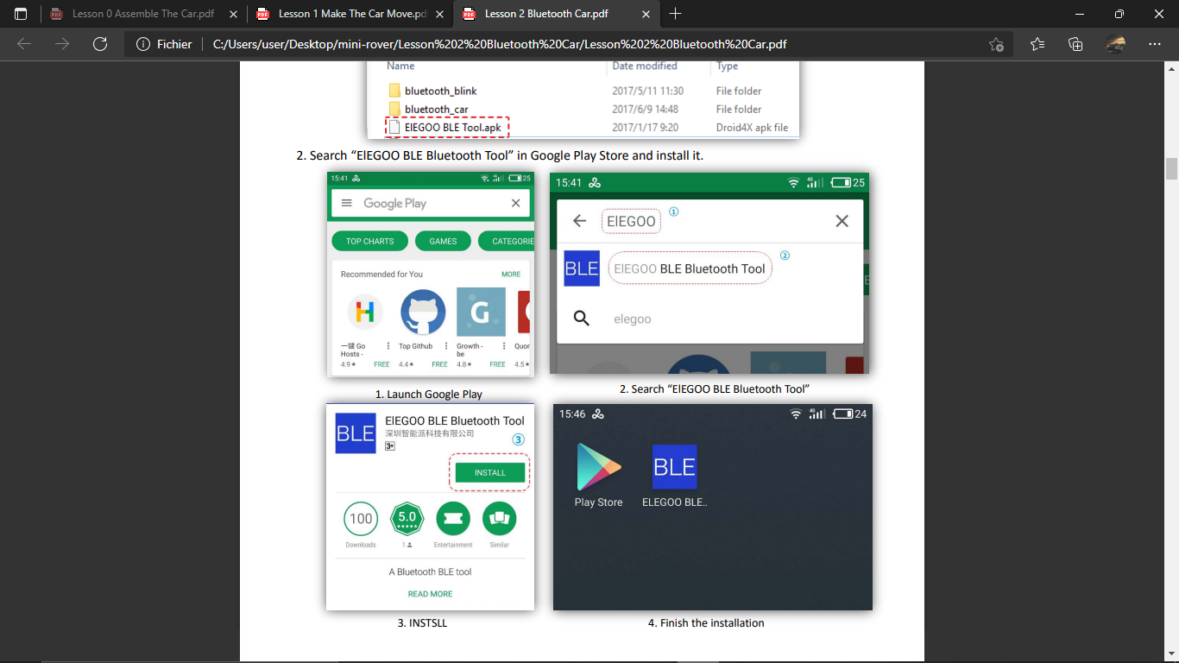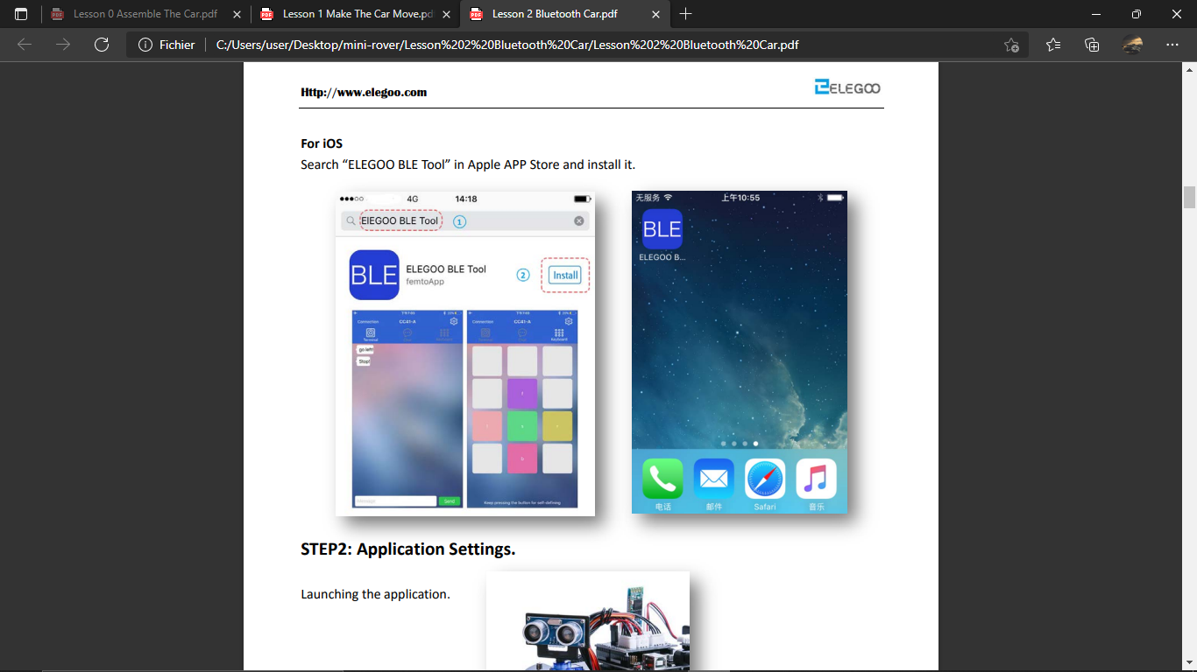

Settings configuration:

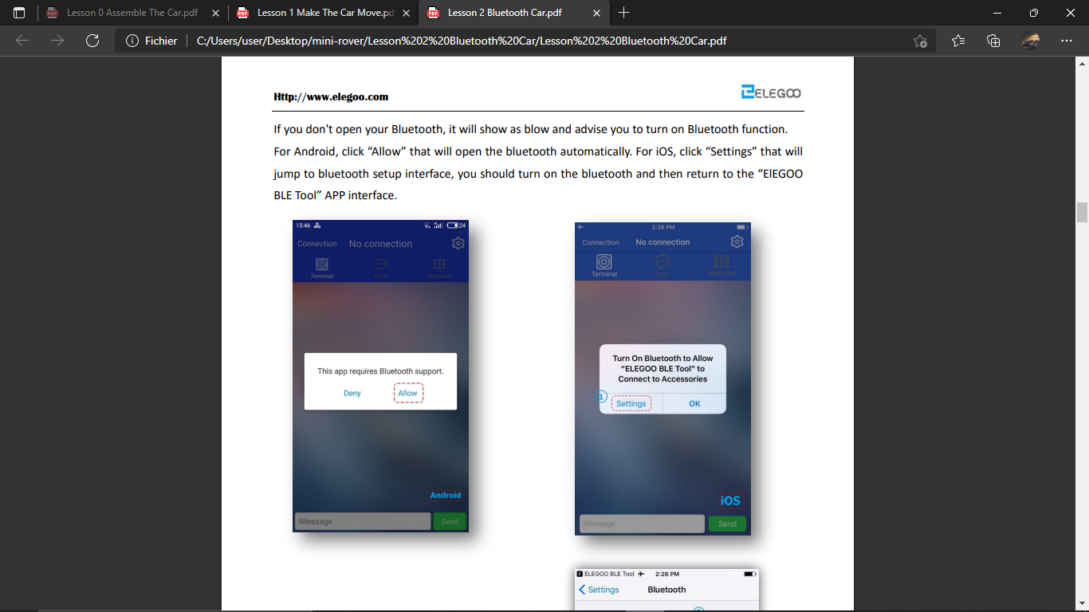

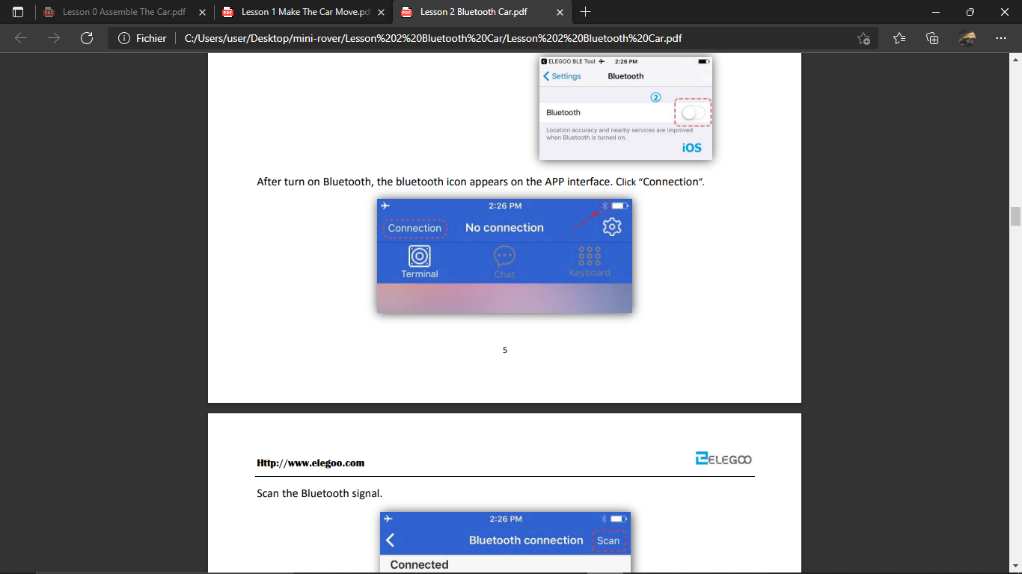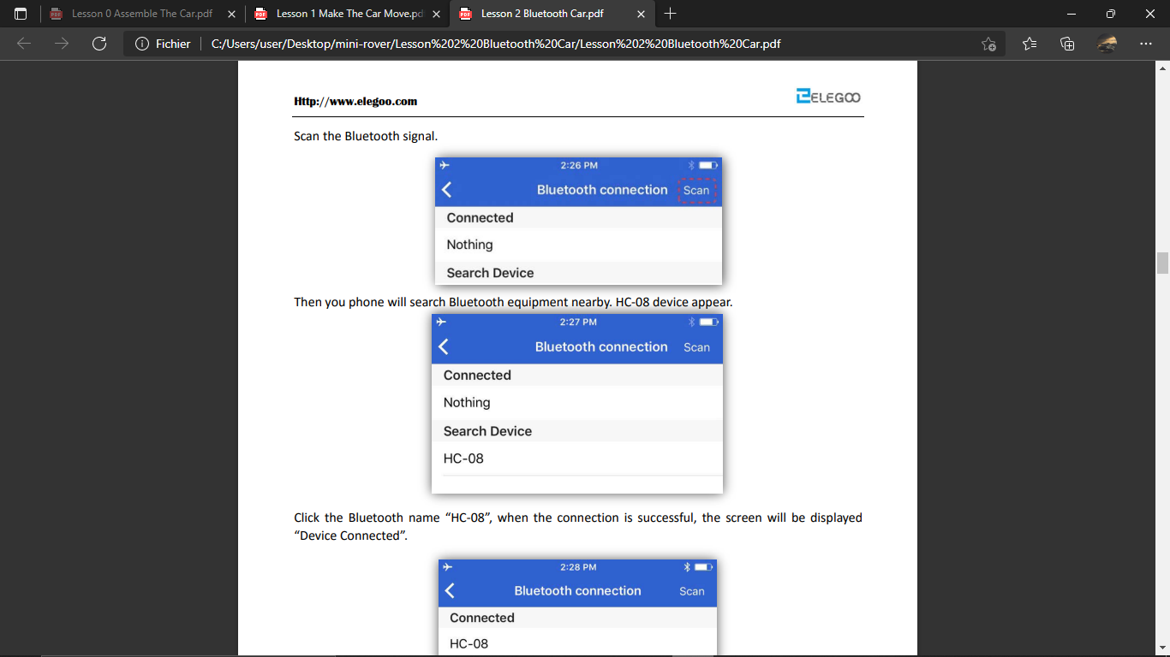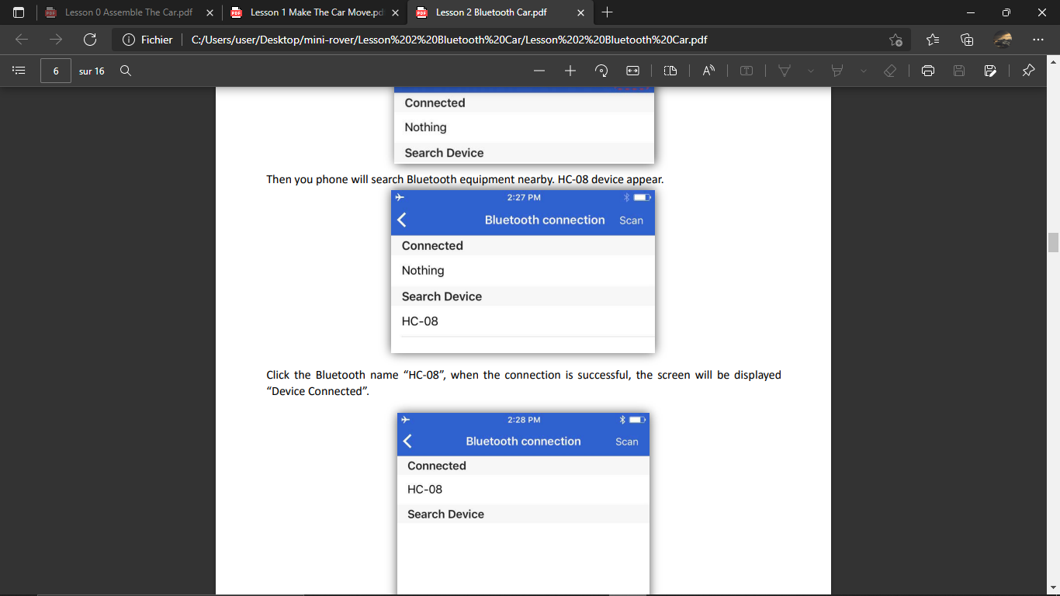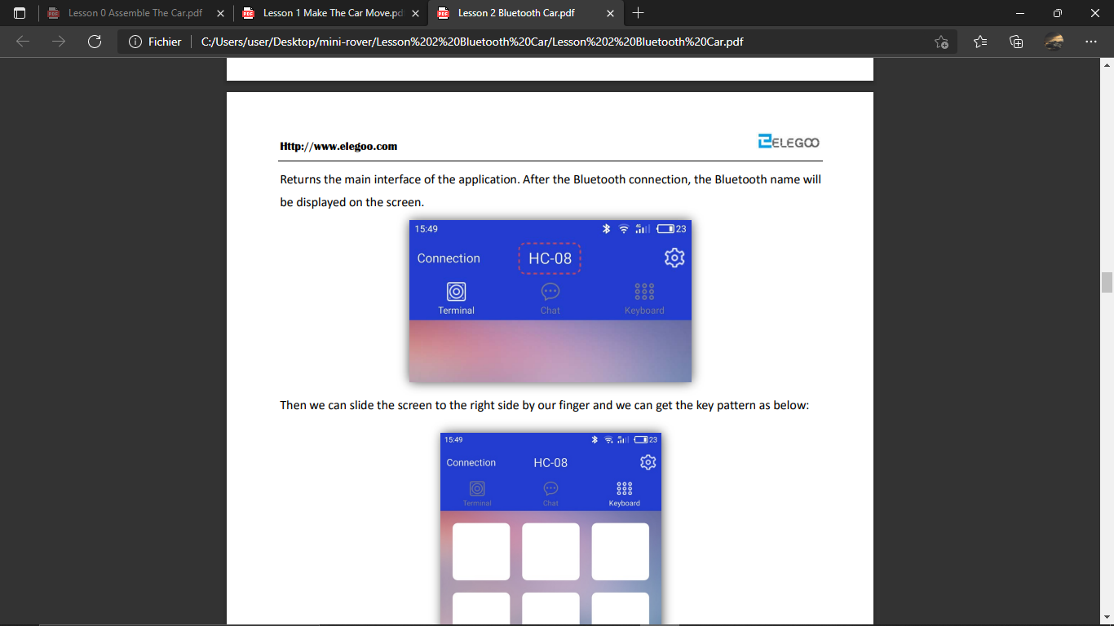

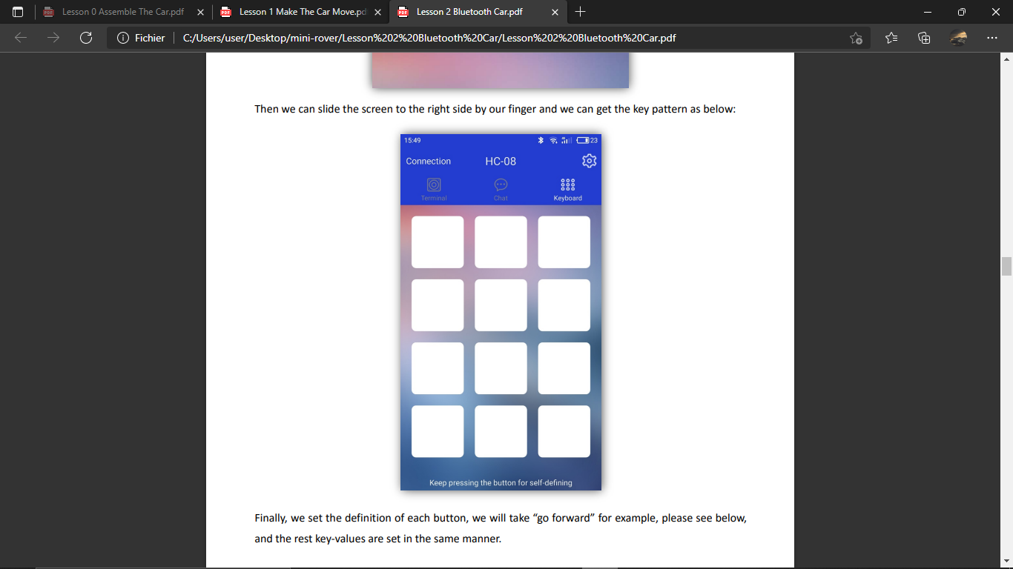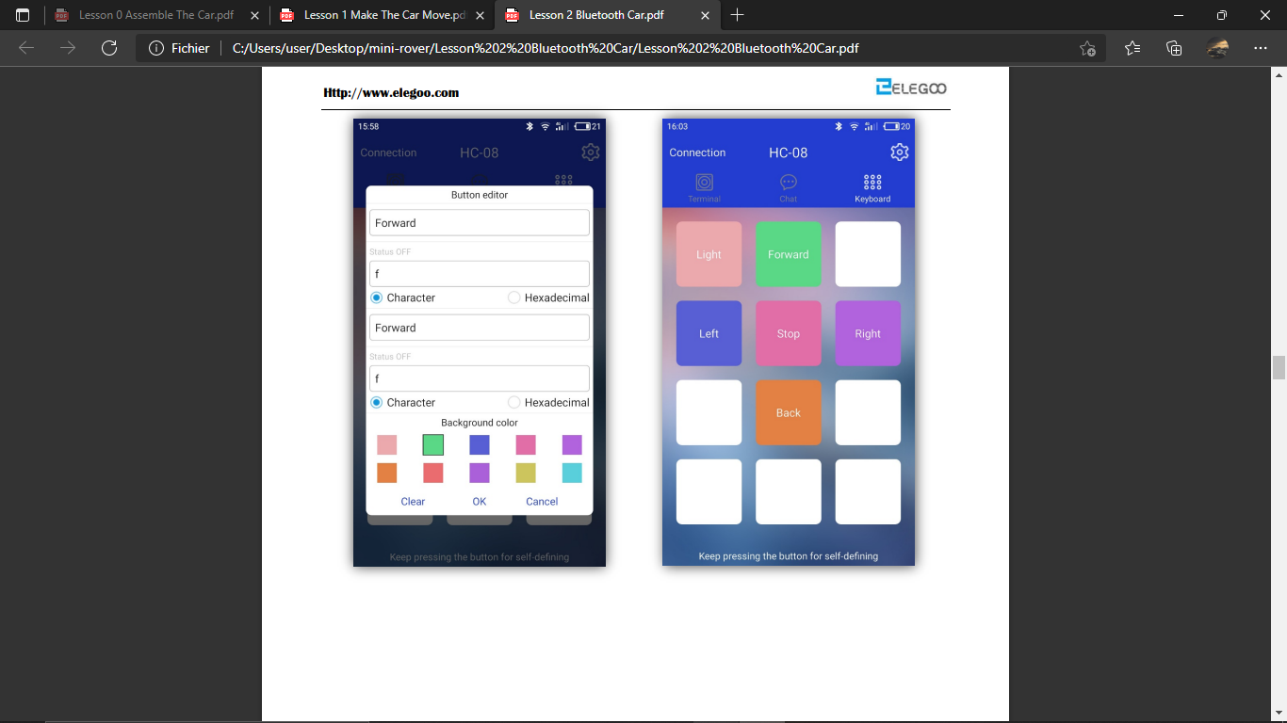

Long press the empty spaces to redefine the buttons and rename them.

## **6.2 Full code:**

#define ENA 5

#define ENB 6

#define IN1 7

#define IN2 8

#define IN3 9

#define IN4 11

#define LED 13

unsigned char carSpeed = 150;

bool state = LOW;

char getstr;

void forward(){

digitalWrite(ENA,HIGH);

digitalWrite(ENB,HIGH);

digitalWrite(IN1,HIGH);

digitalWrite(IN2,LOW);

digitalWrite(IN3,LOW);

digitalWrite(IN4,HIGH);

Serial.println("Forward");

}

void back(){

digitalWrite(ENA,HIGH);

digitalWrite(ENB,HIGH);

digitalWrite(IN1,LOW);

digitalWrite(IN2,HIGH);

digitalWrite(IN3,HIGH);

digitalWrite(IN4,LOW);

Serial.println("Back");

}

void left(){

analogWrite(ENA,carSpeed);

analogWrite(ENB,carSpeed);

digitalWrite(IN1,LOW);

digitalWrite(IN2,HIGH);

digitalWrite(IN3,LOW);

digitalWrite(IN4,HIGH);

Serial.println("Left");

}

void right(){

analogWrite(ENA,carSpeed);

analogWrite(ENB,carSpeed);

digitalWrite(IN1,HIGH);

digitalWrite(IN2,LOW);

digitalWrite(IN3,HIGH);

digitalWrite(IN4,LOW);

Serial.println("Right");

}

void stop(){

digitalWrite(ENA,LOW);

digitalWrite(ENB,LOW);

Serial.println("Stop!");

}

void stateChange(){

state = !state;

digitalWrite(LED, state);

Serial.println("Light");  
}

void setup() {

Serial.begin(9600);

pinMode(LED, OUTPUT);

pinMode(IN1,OUTPUT);

pinMode(IN2,OUTPUT);

pinMode(IN3,OUTPUT);

pinMode(IN4,OUTPUT);

pinMode(ENA,OUTPUT);

pinMode(ENB,OUTPUT);

stop();

}

void loop() {

getstr = Serial.read();

switch(getstr){

case 'f': forward();

break;

case 'b': back();

break;

case 'l': left();

break;

case 'r': right();

break;

case 's': stop();

break;

case 'a': stateChange();

break;

default: break;

}

}

# Full 3ellissa Jr. Course:

Link to course [here](https://docs.google.com/document/u/0/d/16z-NS02GkxzUv2EH1PHvdz-nlGVOE7gr-INt8E1KiOY/edit).

## **7.1 Our Meeting Gallery:**

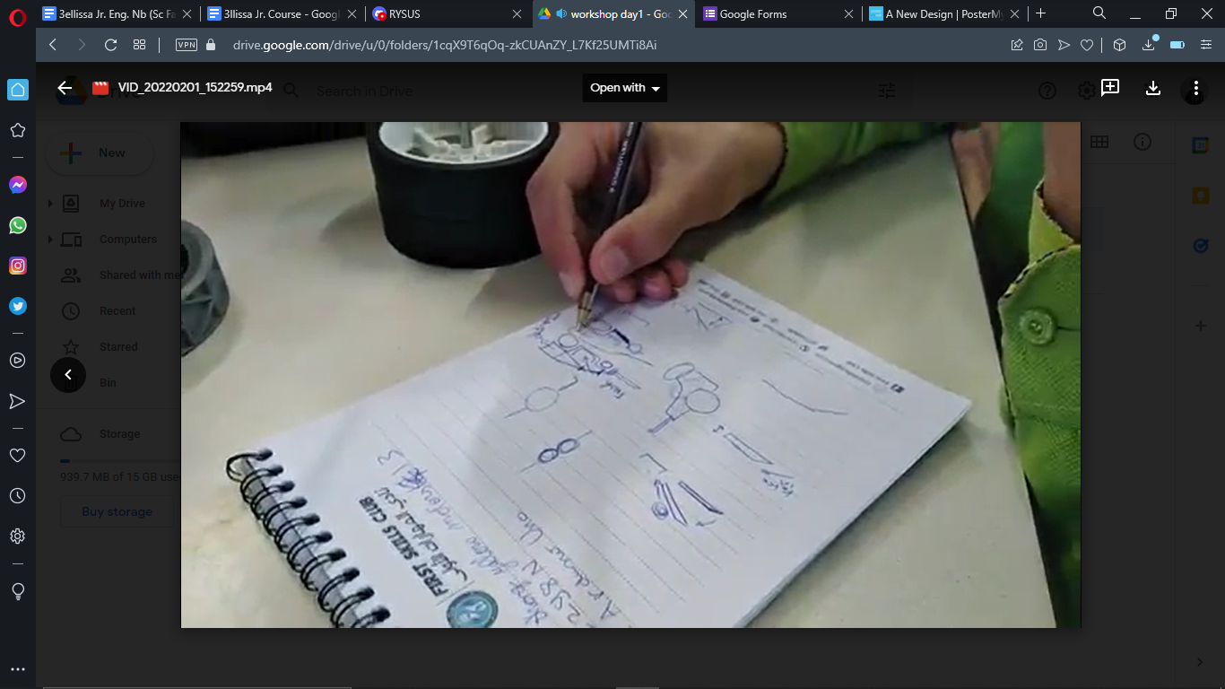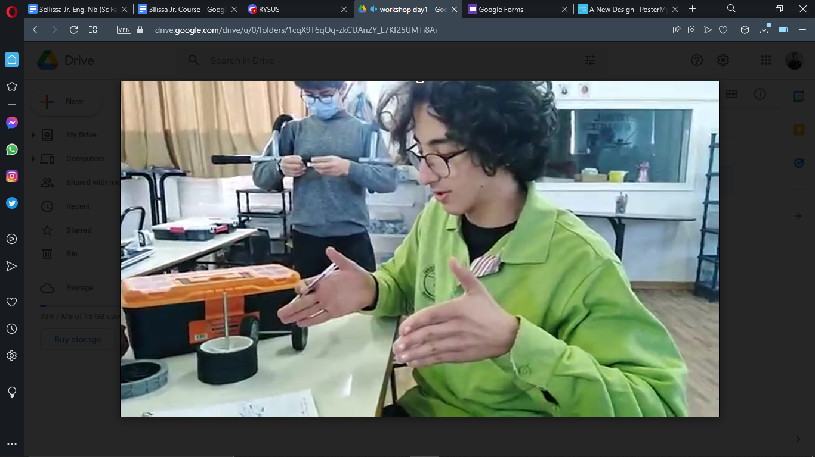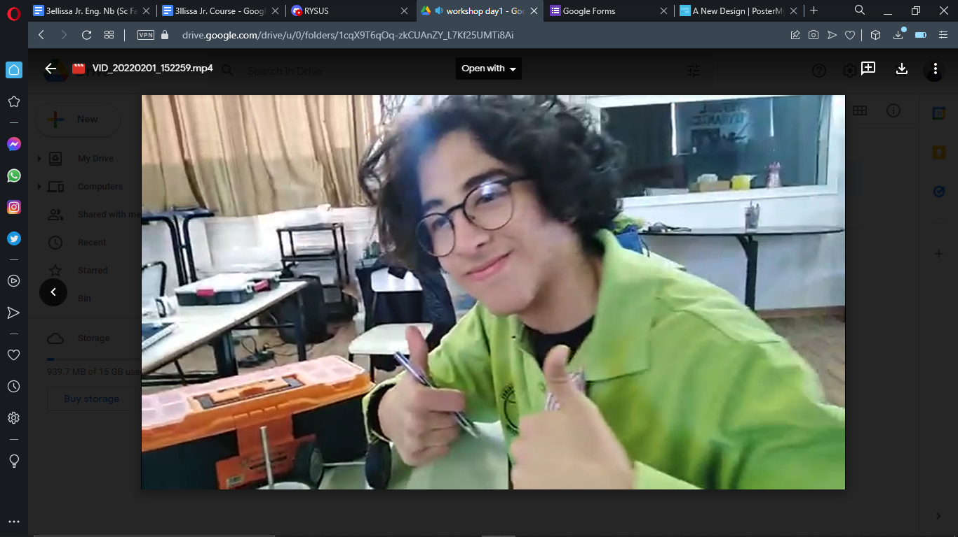

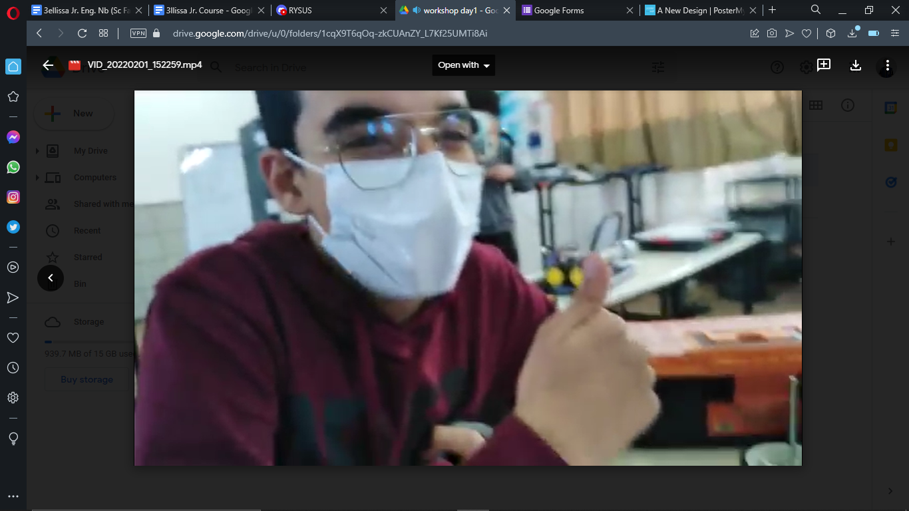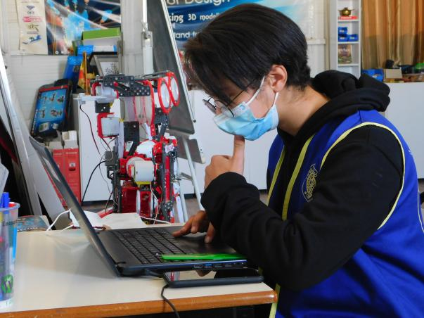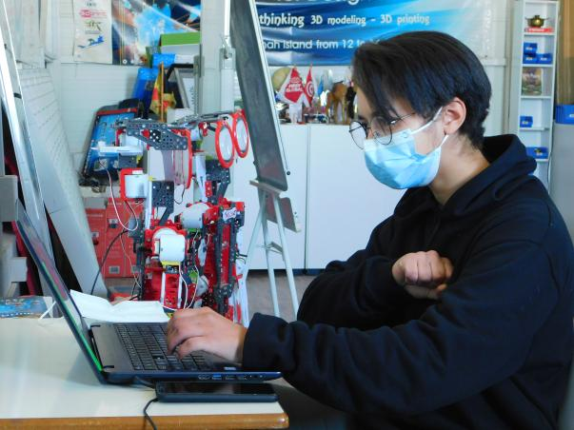

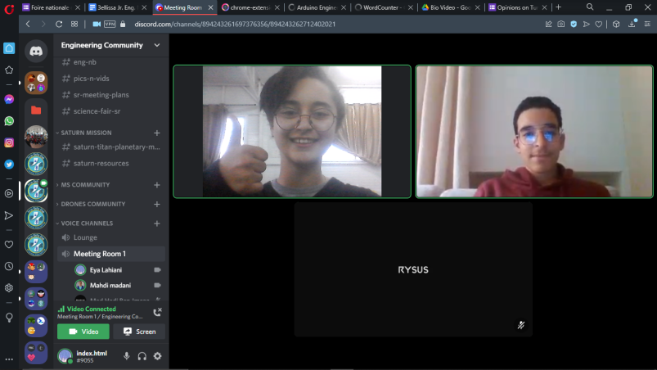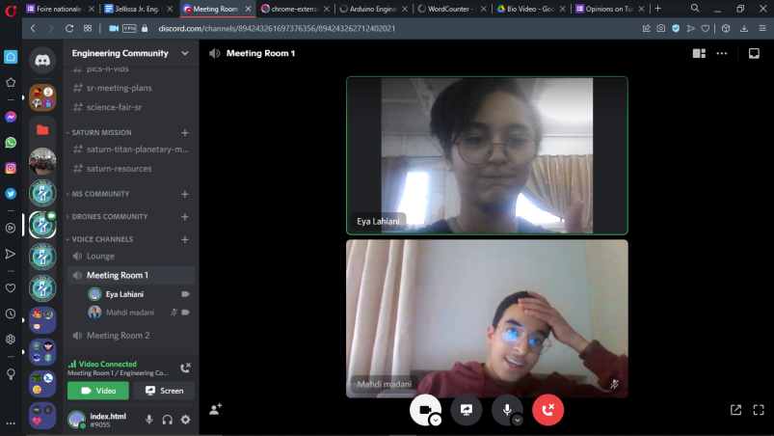

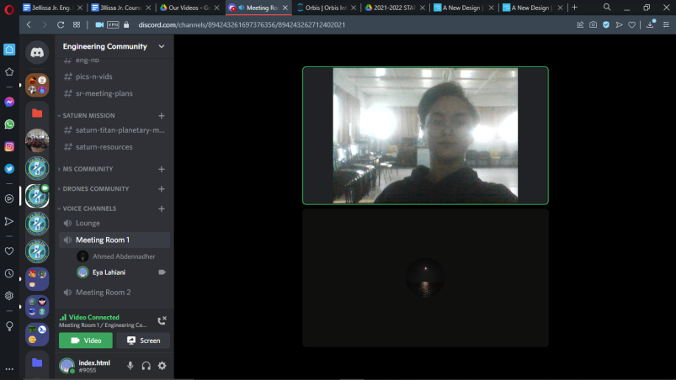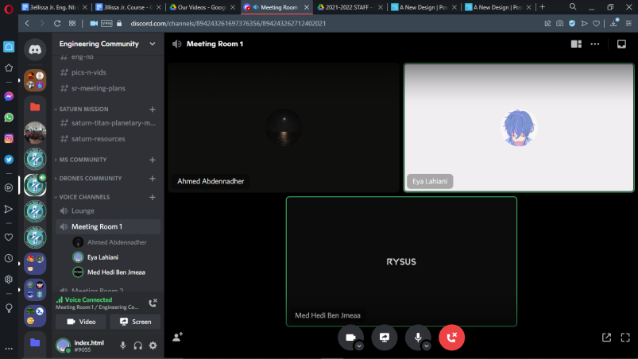

Wanna get in the mood of our meetings and workshops? Make sure to check out our latest updates put out in our Drive, [here](https://drive.google.com/drive/folders/1CL0j-1gkBdViK7MftEB-bIdMQGEJdKMS?usp=sharing).

# Resources & Credits:

Designing the rover: <https://www.mathworks.com/matlabcentral/fileexchange/68789-control-mobile-rover-using-an-android-device>

<https://www.mathworks.com/help/supportpkg/arduino/ug/aek-webcam-rover-example.html>

<https://www.mathworks.com/campaigns/products/arduino-kit.html>

Learning more about the electronics: <https://www.researchgate.net/figure/Illustration-of-L298N-Dual-H-Bridge-Motor-Driver_fig2_335517346>

<https://alselectro.wordpress.com/2014/10/21/bluetooth-hc05-how-to-pair-two-modules/>

<https://youtu.be/RG76c8-CgGA>

<https://youtu.be/EWzk-_dXcmo>

<https://youtu.be/cIpXCbzgRDA>

<https://youtu.be/nv2FbwjIZRE>

<https://youtu.be/vyZwYuF-wi0>

<https://youtu.be/Ox-9eOc3bQU>

Drawing & Editing:

<https://pixlr.com/fr/x/>

Our sharing software (Drive): <https://drive.google.com/drive/folders/1nI3-r4QOhbnleLTW8T_0_S0ngkLl_n7o?usp=sharing>

Video Recording and meeting place:

<https://chrome.google.com/webstore/detail/screen-recorder-screensho/igkkmokkmlbkkgdnkkancbonkbbmkioc/related?hl=en&gclid=Cj0KCQiA9OiPBhCOARIsAI0y71AgBovgz2YWIOcw5aGZ-uP9be94sG2KrIot9Jm2iNWtzJ4OYyzHDGkaAp9REALw_wcB>

And Discord.com

**Thanks to everyone who has he-lped us with our research through filling the form we have put out:**

benamaremna42@gmail.com

yessineyessine000@gmail.com

chahd.madani@gmail.com

neyrouzchekir01@gmail.com

ahmed.aabdennadher@gmail.com

wardahamani2005@gmail.com

walidabdelmoula3@gmail.com

nourkhbou123@gmail.com

mohamedazizzaghla@gmail.com

ahmedkammoun045@gmail.com

anashakim664@gmail.com

hbiba.ab@gmail.com

rayen.zouari.2007.04.03@gmail.com

kharratchaima642@gmail.com

bayram.kaaniche.2.2020@gmail.com

mohamedgd10@gmail.com

mahsoundrira@gmail.com

zaynouba.kamoun@gmail.com

nourtriki2008@gmail.com

zeinebkammoun26@gmail.com

aymenakid8@gmail.com

ouledabdallahyoussef@gmail.com

ibrahimchabchoub9@gmail.com

yemenkrichenb9@gmail.com

farahinfoo0@gmail.com

yacineboujelbenne@gmail.com

benhassenyomna12@gmail.com

benhajislem11@gmail.com

eyaaakid@gmail.com

hazemmnif@gmail.com

asmamallek9@gmail.com

ismailcharfeddine123@gmail.com

aalhakim18@gmail.com

yosrfawzi192@gmail.com

rabdennadher789@gmail.com

yassine.chakroun2006@gmail.com

tmes.radhouane@gmail.com

salimhadrich20@gmail.com

yassine.ktari.18@gmail.com

youssef.zribi2020@gmail.com

molka392@gmail.com

alaeddinetoumiattia@gmail.com

ninigigi078@gmail.com

amenigharbi1016@gmail.com

walarouis@gmail.com

issra.gam2005@gmail.com

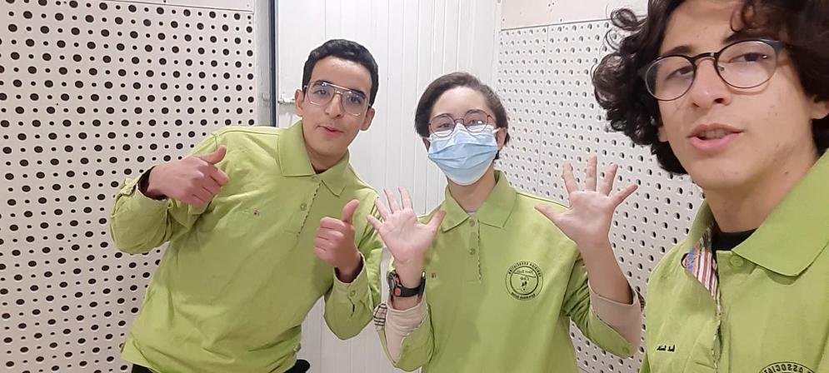

– Us, E. Lahiani, M. Madani and M. H. Ben Jmeaa, in 01/02/202

All rights reserved ©TeamAres 2022

Contact us: [Teamares.tunisia@gmail.com](mailto:Teamares.tunisia@gmail.com) / 20 513 102.

